WEEK 4 – SPL 4 – POLYMERS
FOR STATISTICS ABOUT POLYMERS CHECK THE PPT !!
THERMOPLASTICS – Heat up more – becomes more plastic – more easy to deform – squeeze to conform new shape – cool it down = new product :)
THERMOSETTING – low viscosity, HIGH TEMP , THERMAL CAPABILITIES THAN THERMOPLASTICS!, can NEVER BE REMELTED!! This is an issue for car tyres as we cant heat up and make into a new material and recycle..
Property / Characteristic | Thermoplastics | Thermosets
Molecular Structure | Mostly linear molecules, with a degree of branching and side chains | Three-dimensional cross-linked network
Recyclability | Re-meltable and recyclable | Cannot be remelted once cured (non-recyclable)
Processing Behaviour | Softens when heated, solidifies when cooled | Starts as a liquid, undergoes chemical curing to harden
Examples | Polyethylene, Polypropylene, ABS, PET, Nylon | Epoxy resin, Unsaturated Polyester
Thermal Properties | Poor high-temp resistance | Good high-temp resistance for polymers
Initial Form | Usually supplied as pellets | Supplied as liquid or pre-polymer resin
Flow During Processing | Flows repeatedly when reheated | Flows once, then cures irreversibly
Viscosity During Processing | High viscosity (like treacle) | Low viscosity (like water) before curing
Typical Use Cases | Packaging, automotive panels, toys | Electrical insulation, adhesives, structural composites

- What does the “Scale of the Industry” data tell us about the economic and employment impact of the polymer sector in Europe, and how might this influence engineering design choices?
The "Scale of the Industry" slide illustrates the massive economic and employment footprint of the polymer sector in Europe (EU, 2012 data):
- Over 1.5 million people were employed in polymer-related industries.
- The value of polymer plastic production €87 billion.
- Conversion of these plastics into usable parts and products reached a €201 billion.
Polymers:
- Mass production due to low cost and scalability
- Lightweight solutions for transportation and energy efficiency
- Customisable properties to meet specific design requirements
Shape Change Process in Polymers
- Polymers are usually processed using a moulding operation involving shape changes in a liquid state.
- At much lower temperatures than those required for metals. Polymers melt and flow at much lower temperatures than metals, reducing energy consumption and thermal stress on tooling.
- At lower pressures and hence lower tooling costs when compared to metals.
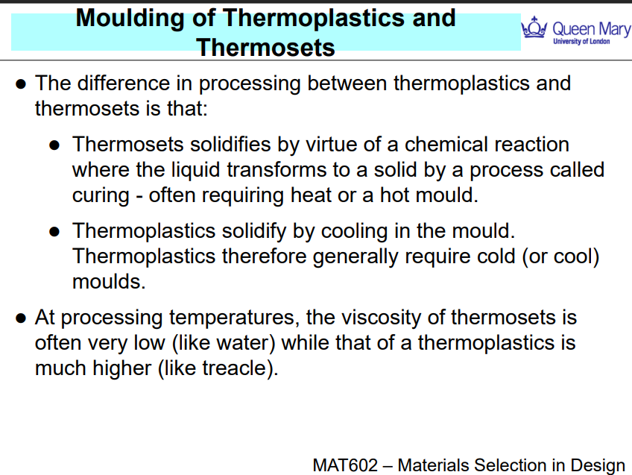
Moulding of Thermoplastics and Thermosets
- THERMOPLASTIC – heat polymer up , squeeze (mold) it into a chamber under pressure (still quite viscous)
Supplied as solid pellets

- THERMOSET – opp of thermoplastic, starts as a really low viscosity fluid, pump it into a chamber, heat up chamber – comes out as solid e.g., epoxy resin more viscous than water but less than e.g., treacle or honey
Supplied as a liquid or semi-liquid resin

INJECTION MOULDING
Injection moulding is a fast, automated process used to convert granular thermoplastic materials into complex, detailed parts. It’s widely used in mass manufacturing e.g.,
Step-by-Step Process:
- Feeding:
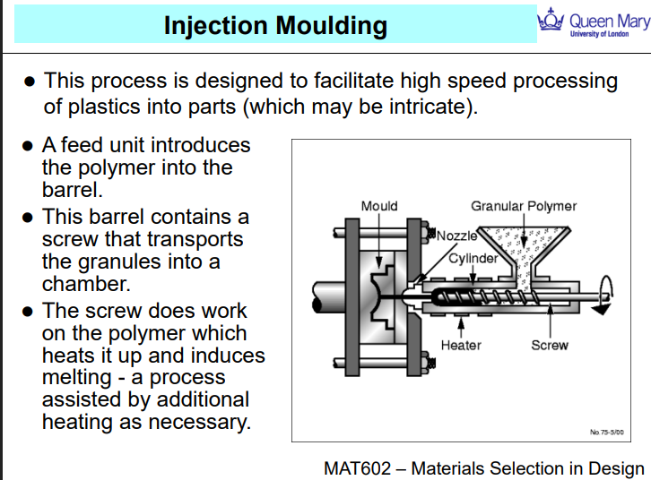
  - Plastic granules (usually thermoplastics) are loaded into a hopper.
  - They drop into a barrel with a rotating screw.
- Heating & Melting:
  - As the screw rotates, it conveys the granules forward.
  - The friction from the screw + external heaters causes the granules to melt into a viscous fluid.
- Injection:
  - Once a full shot of molten polymer is ready, the screw acts as a plunger, pushing the melt through a nozzle into the mould cavity.
- Cooling & Ejection:
  - The polymer cools and solidifies in the mould (which is kept cold).
  - The mould then opens, and the part is ejected.

Other forms of Injection Moulding
Gas-Assisted Injection Moulding
- Involves injecting gas (usually nitrogen) into the mould after the polymer.
- The gas pushes the molten plastic outward, creating hollow sections inside the part.
- Advantages:
  - Reduces material usage
  - Makes parts lighter
  - Helps produce thicker, more uniform walls
- Common in: back of TV
Co-injection moulding - mould multiple polymers into a single part
Advantages:
- Combines cost-efficiency and performance
- Useful for products needing aesthetic finish + strength
Scrim
Uses multiple injection barrels with one tool.
After filling the mould, oscillating pressure is applied before the polymer solidifies.
Advantage:
- Create preferred molecular alignment (orientation)
- Reduce voids and improve part quality
Downside: It's expensive and can damage moulds due to pressure cycling.
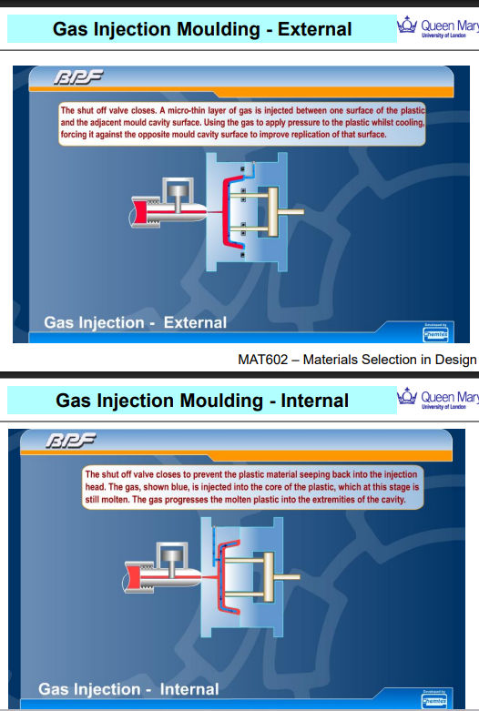
External Gas Injection Moulding: THERMOPLASTIC
- A thin layer of gas is injected between the outer surface of the molten polymer and the mould wall.
- The gas pushes the polymer tightly against the opposite mould surface.
- This helps to replicate fine surface details while maintaining hollow interiors.
Used for:
- Parts where external appearance and surface detail are important.
- Creating uniform outer surfaces with reduced material use.

Internal Gas Injection Moulding:
- The gas is injected into the core of the molten plastic, while it’s still inside the mould.
- The gas pushes the plastic outward, forcing it to fill the mould extremities.
- It also helps create hollow sections, reducing weight and material.
Used for:
- Producing hollow parts with thick sections (e.g., handles, tubes).
- Ensuring complete fill of complex geometries without sink marks.
EXTRUSION PROCESSES - thermoplastic
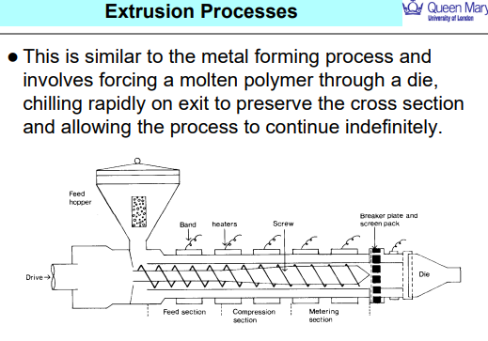
EXTRUSION - continuous polymer shaping process used to produce parts with a constant cross-section, such as pipes, tubes, window frames, and plastic sheets.

Blow Moulding - e.g. bottles
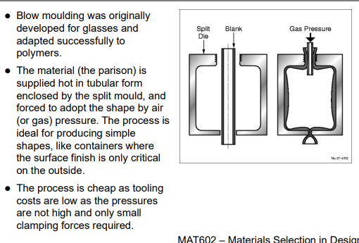
- A molten polymer tube (called a parison) is extruded vertically.
- The parison is enclosed within a split mould.
- Compressed air or gas is then blown into the parison.
- The pressure causes the polymer to expand and press against the mould walls, taking its shape.
- The plastic cools and hardens in that form.
- The mould opens and the final part is ejected

Vacuum Forming
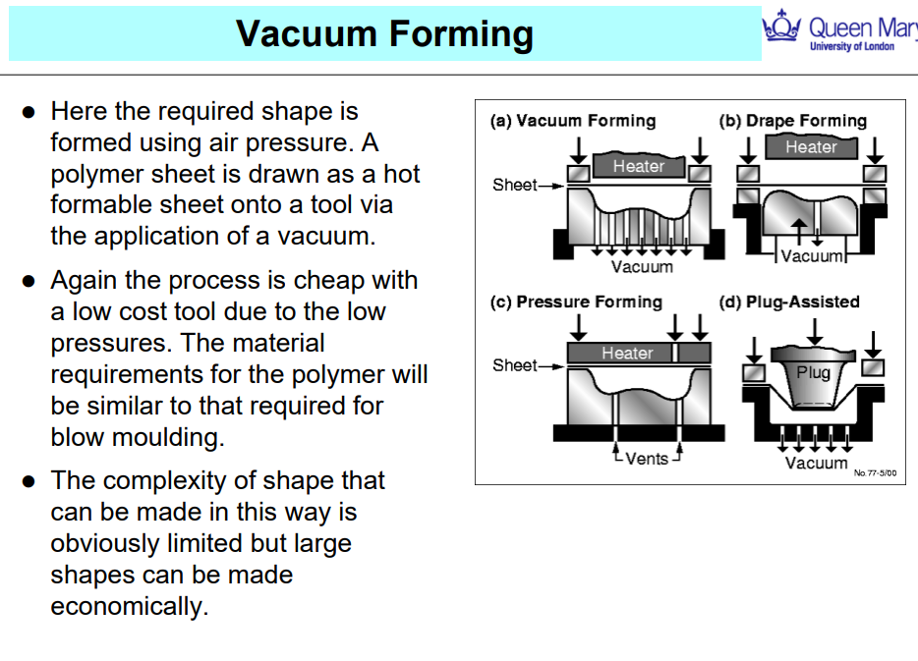
- A vacuum is applied beneath the mould, sucking the sheet into its shape.
- The sheet cools and hardens, taking on the mould’s contours.
- (a) Vacuum Forming – Basic form using suction only
- (b) Drape Forming – Sheet sags over the mould before vacuum is applied
- (c) Pressure Forming – Uses vacuum plus extra air pressure on top
- (d) Plug-Assisted Forming – A plug pushes the sheet into the mould before vacuum is applied, improving accuracy

BLOWN FILM – PLASTIC BAG

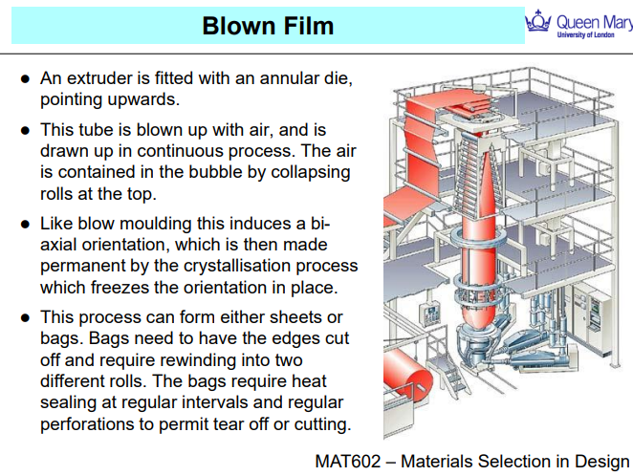

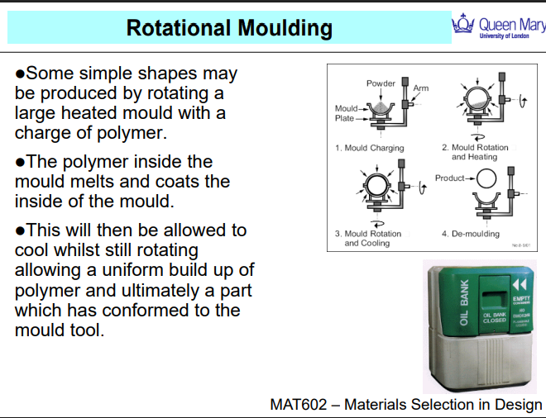
Rotational Moulding

- A pre-measured amount of thermoplastic powder is placed inside a hollow metal mould.
- The mould is sealed.
- As the mould rotates, the plastic powder melts and coats the interior surface evenly.
- Powder - melted and distributed, the mould is cooled, typically by air or water mist.
- The mould is then opened, and the solidified part is removed.
e.g., water tanks, storage bins and etc.

Cost Comparison
INJECTION MOUDLING – MACHINERY EXPENSIVE BUT EASY TO PRODUCE A BATCH
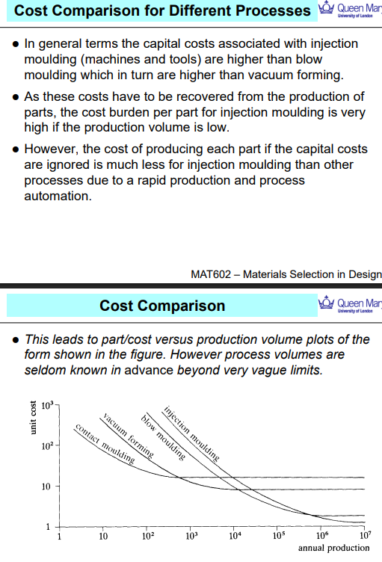

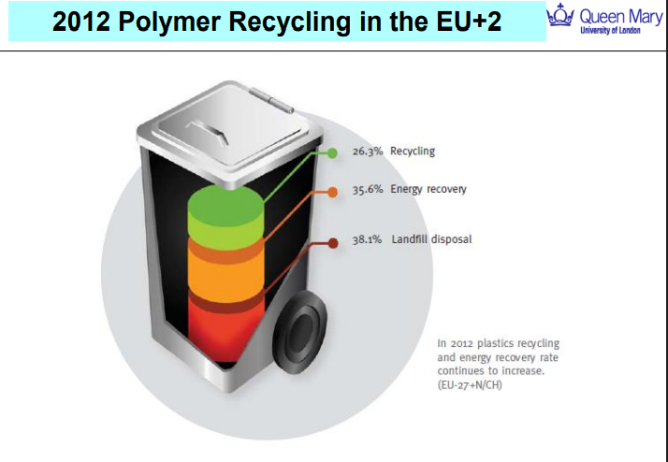

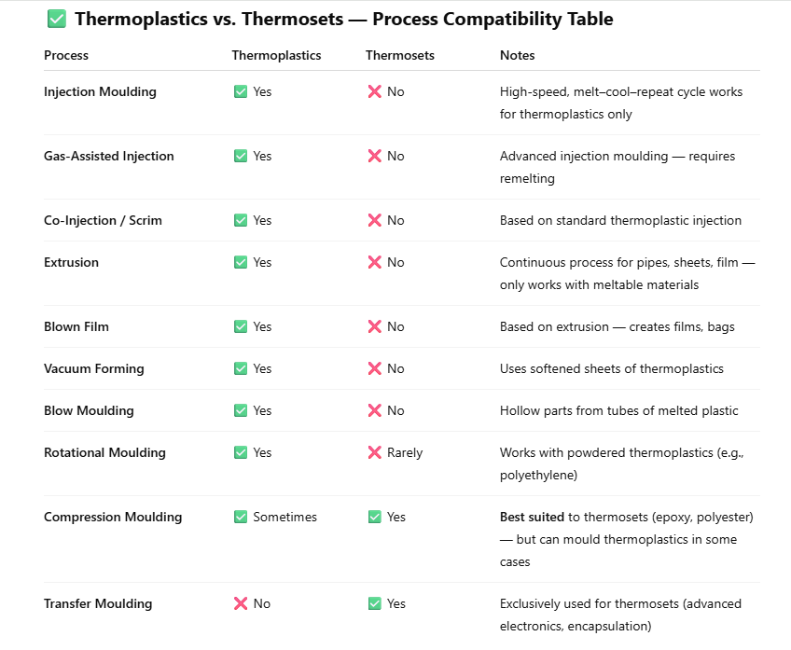

Method | Advantages | Disadvantages
Injection Moulding | High precision and repeatability  Fast cycle times for mass production  Good surface finish | High tooling cost  Limited to thermoplastics  Difficult for very large parts
Gas-Assisted Injection Moulding | Hollow parts with less material  Reduces warping and sink marks  Good for complex shapes | More complex tooling  Process control is critical  Only for thermoplastics
Extrusion | Continuous process  Excellent for long, uniform profiles  Low material waste | Limited to simple cross-sections  Surface finish may need post-processing
Blown Film Extrusion | Produces thin, biaxially oriented films  High throughput  Ideal for packaging | Limited to thin film products  Requires precise control
Blow Moulding | Great for hollow containers (e.g., bottles)  Low cost for large volumes  Good for thin-walled parts | Poor control over wall thickness  Limited to simple shapes
Vacuum Forming | Low tooling costs  Fast setup for low-volume production  Simple equipment | Limited to shallow parts  Poor detail resolution  Only one good surface
Rotational Moulding | Uniform wall thickness  Ideal for large hollow items  No seams or welds | Long cycle time  Lower detail accuracy  Not suitable for small intricate parts
Compression Moulding | Good for thermosets  Low scrap rate  Can mould large parts | Limited to simple geometries  Slower than injection moulding  Labour intensive

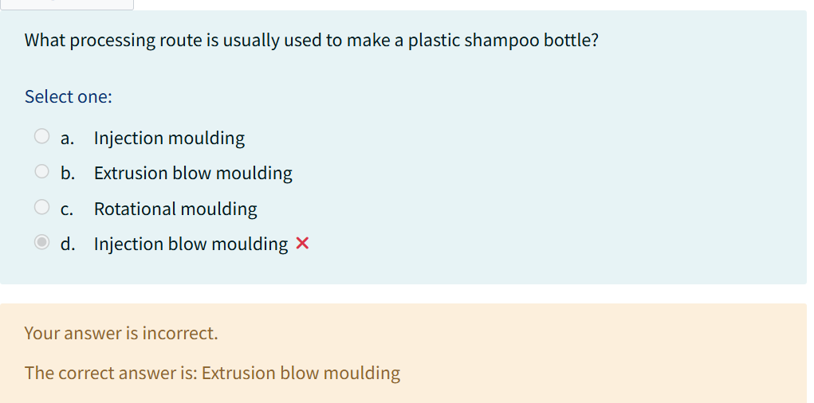
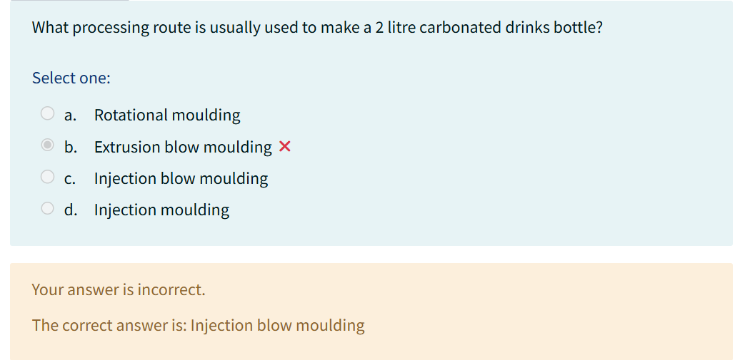
Feature/Aspect | Injection Blow Moulding | Extrusion Blow Moulding
Used for | High-precision containers (e.g., carbonated drink bottles, pharma bottles) | Larger or simpler hollow products (e.g., shampoo bottles, detergent containers)
Preform shape | Starts with an injection-moulded preform (precise neck & threads) | Starts with a tube (parison) extruded from a die
Neck finish | Excellent dimensional control – smooth, threaded, leak-proof | Less accurate – rougher or simpler necks
Wall thickness control | Very uniform wall thickness | Variable wall thickness unless controlled with die design
Material | Often PET (polyethylene terephthalate) | Often HDPE, LDPE, or PP
Cost & speed | Higher precision, lower speed, more expensive | Faster, cheaper, great for mass production
Examples | Water/soda bottles, small pharma vials | Shampoo bottles, milk jugs, fuel tanks

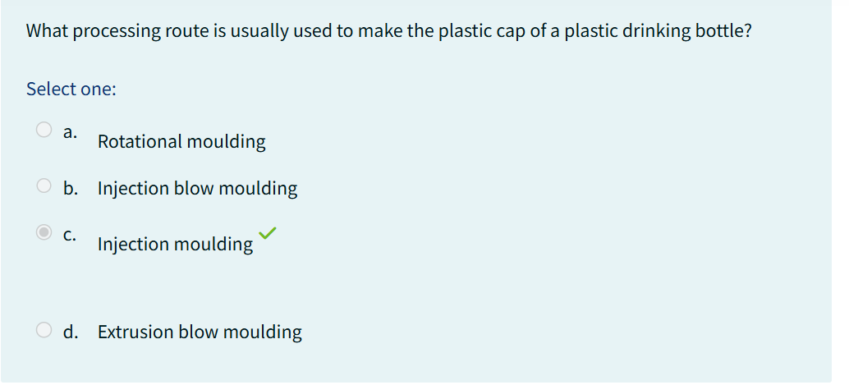
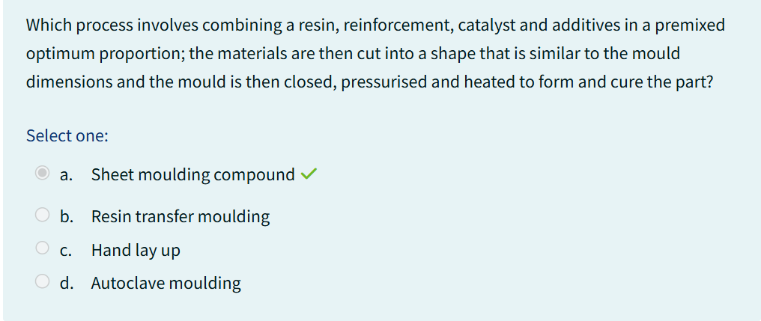

SPL 4 – COMPOSITES
Specific stiffness and specific strength are material efficiency metrics that compare a material's mechanical performance relative to its weight.
- Specific Stiffness = Young’s Modulus / Density
→ Measures how stiff a material is per unit weight
- Specific Strength = Strength / Density
→ Measures how strong a material is per unit weight
These properties are critical in industries like aerospace, automotive, and sports equipment, where materials must be lightweight but still mechanically robust.
1.Why are composites increasingly used in aircraft like the Boeing 787, and what benefits do they provide over traditional materials?
The aerospace industry has shifted heavily toward composites due to their exceptional specific strength and stiffness, as well as their resistance to environmental degradation.
In the Boeing 787 Dreamliner:
- Over 50% of the structural weight comes from composites, primarily carbon fibre-reinforced polymers (CFRPs).
Key Benefits of Composites in Aircraft:
- Weight Reduction:
  - Composites are significantly lighter than metals, reducing overall aircraft weight.
  - Less weight = better fuel efficiency and lower emissions.
- High Strength & Stiffness:
  - CFRPs provide excellent load-bearing capabilities with low density.
  - Critical for wings, fuselage panels, and control surfaces.
- Corrosion & Fatigue Resistance:
  - Unlike metals, composites do not corrode and are less prone to fatigue failure.
  - This reduces maintenance costs and extends service life.
- Manufacturing Flexibility:
  - Composites can be moulded into complex, integrated shapes, reducing the number of rivets, joints, and fasteners.
  - Improves aerodynamic efficiency and reduces assembly time.
The United States plays a leading role in the global composites market in both value and volume. This highlights the country's strong adoption of composite technologies across sectors.
- The USA accounts for 36% of the global composites market by value (~€22 billion).
- It also contributes 35% of the total volume (2.7 million metric tons).
- Composites make up 16% of the USA’s structural materials market, compared to:
  - Steel: 76%
  - Aluminium: 8%
This shows that while metals still dominate, composites are steadily gaining market share — especially in sectors requiring high performance-to-weight ratios.
Global Comparison – Per Capita Use:
- USA: 8–9 kg per person
- China: 1–2 kg per person
2.What’s the difference between isotropic and anisotropy?
Isotropic Materials:
- Same properties in all directions.
- Includes most metals, plastics, and ceramics.
- Design and analysis are simpler because behaviour is uniform no matter how you load the material.
Anisotropic Materials (like composites):
- Properties vary with direction, especially with fibre-reinforced composites.
- The mechanical performance depends on how the fibres are aligned.
- The processing route (e.g., layup orientation) and the final part properties are interdependent — meaning you can't separate design from manufacturing.
Initial Design Considerations:
When designing with composites, ask:
- What’s the performance objective?
- What’s the most cost-effective way to arrange fibres and embed them in the matrix?
- What processing method (e.g., hand layup, filament winding) ensures correct orientation?

3. What are the three essential components of a composite material, and how does each contribute to the final performance of the part?
1. Fibre (Reinforcement):
- The load-bearing element of the composite
- Provides strength, stiffness, and directional performance
- Common fibres:
  - Glass fibre – affordable, good strength
  - Aramid (Kevlar) – high toughness, impact resistance
  - Carbon fibre – high stiffness and low density
2. Matrix (Binding Phase):
- The glue that binds fibres together and transfers stress between them
- Protects fibres from mechanical damage and environmental degradation
- Types of matrices:
  - Thermosets: Epoxy, polyester → rigid, high-temperature resistance
  - Thermoplastics: PEEK, polyimide → more ductile, recyclable
3. Interface (Interphase Region): CHATGPT
- The boundary layer between fibre and matrix
- Critical for load transfer — poor bonding = weak composite
- Influenced by:
  - Surface treatment of fibres (e.g., sizing agents)
  - Manufacturing conditions (e.g., temperature, pressure, cure cycle)
JAMES: interface = weak therefore need stress transform from fibre to fibre therefore need to make sure interface is strong. What this means:
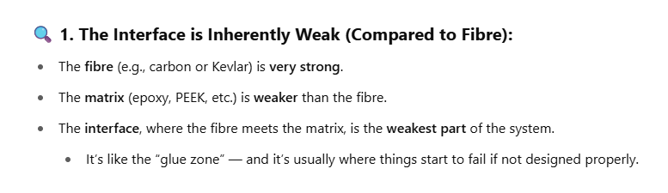
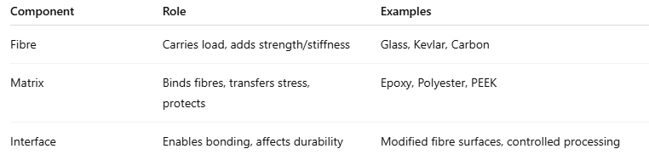
What are thermosetting matrix composites, and how do their processing characteristics influence manufacturing?
Thermosetting matrix composites use a thermosetting resin (i.e., a liquid that cures irreversibly) as the binding phase to hold and transfer stress between fibres. These are the most widely used composites in structural applications.
Key Characteristics:
- Low Viscosity Resin:
  - Thermoset resins start off as low-viscosity liquids.
  - This makes them easy to flow, allowing them to wet the fibres completely during layup or injection.
  - Ensures good fibre–matrix bonding (critical for mechanical performance).
- Then combines with Solid Fibres:
  - Fibres (like carbon, glass, aramid) are laid into position (e.g., woven mats, roving, tapes).
  - The liquid resin flows around the fibres, forming the composite structure.
- Then it undergoes curing reaction:
  - The matrix then chemically cures (usually with heat and/or catalyst).
  - This cross-linking process transforms the resin into a rigid, thermoset plastic.
  - Once cured, the composite cannot be reshaped or remelted — it's permanently set.
- Fibre Flexibility:
  - Fibres can be pre-shaped or layered in various forms, allowing flexibility in design and tailoring of mechanical properties.
Resin Type | Key Properties
Unsaturated Polyester | Cheap, good for boat hulls, automotive
Vinyl Ester | Better chemical resistance than polyester
Epoxy | Strong, excellent adhesion, low shrinkage
Bismaleimides | High-temp resistance (aerospace)
Polyimides | Excellent thermal and chemical resistance
Phenolics | Fire resistance, often in electrical uses
Furanes & Urethane-Acrylates | Specialised roles, flexible chemistry options
Fibre forms used in thermosetting composites:
Continuous Roving:
- Consists of thousands of continuous fibres bundled together
- Relatively cheap and can be aligned during processing
- Used in processes like filament winding, pultrusion
- Provides high directional strength if aligned well
Chopped Glass Fibre Mats:
- Made from short random fibres
- Very low-cost
- Easy to handle and process, but produces non-directional properties – AS RANDOM COMPOSITES
- Used in automotive panels, tubs, low-stress parts

Continuous Filament Mats: SIMILAR TO CHOPPED
- Continuous fibres, but laid in random or semi-aligned orientations
- Slightly stronger than chopped mats
- More expensive than chopped fibre but better mechanical consistency
Fibre Form | Key Feature | Benefit
Tri-axial Weaves | 3-way reinforcement | Balanced strength, multi-axial loads
Non-woven Multi-axial | Stitched layers, no crimping | High performance, tailored directions
Braided/Knitted Preforms | 3D shapes | Automated, complex geometries

CONTACT MOULDING ARE HAND AND SPRAY LAY UP
Process | Method Steps
Hand Lay-Up | Place fibres manually on mould, wet with resin, roll to remove air, cure.
Spray-Up | Spray resin and chopped fibres onto mould, allow to cure.
RTM | Place dry fibres in closed mould, inject resin under pressure, cure.
Filament Winding | Pull fibres through resin bath, wind on rotating mandrel, cure.
Pultrusion | Pull fibres through resin and heated die, cure as continuous profile.
Hot Press Moulding | Place pre-filled moulding compound in hot mould, compress, cure.
Prepreg Autoclave | Lay pre-impregnated fibres in mould, consolidate in autoclave under heat and pressure.

Process | Description | Typical Products | Advantages | Disadvantages
Hand Lay-Up | Fibres manually placed on mould and wetted with resin by brush; cured | Boat hulls, storage tanks | Simple, low cost, large parts | Low speed, labour-intensive, inconsistent quality
Spray-Up | Resin and chopped fibres sprayed onto mould using spray gun | Baths, cladding panels | Fast, portable, low cost | Only random fibres, one good surface, quality varies
Resin Transfer Moulding (RTM) | Dry fibres placed in mould, resin injected under pressure | Car doors, water tanks | Good surface finish, inserts possible, suitable for volume | Lower fibre volume fraction, strength not optimal
Filament Winding | Fibres soaked in resin wound onto rotating mandrel | Tubes, fishing rods | High strength, precise fibre placement | One good surface, slow, limited shapes
Pultrusion | Fibres pulled through resin bath and heated die to cure | Beams, ladders | Continuous profiles, high volume | Limited to constant cross-sections
Hot Press Moulding | Compression or injection moulding with pre-filled resin | Automotive components | High volume, short cycle time | Expensive tooling, fibre damage possible
Prepreg Autoclave | Pre-impregnated fibre sheets laid in mould, cured under heat and pressure in autoclave | Aerospace, F1 parts | Excellent quality, high performance | Very expensive, slow, high skill required

LECTURE 7
What is Casting? USES LOWER VISCOSITY LIQUIDS !!
Casting involves:
- Pouring a liquid (usually molten metal) into a mould cavity.
- Letting it solidify either:
  - By cooling (as with metals), or chemical reaction (as with thermosets/elastomers).
- Removing the solid part once it sets.
🧪 How the Mould is Filled:
- Gravity Casting – Liquid flows in under its own weight (simple and cheap).
- Centrifugal Casting – Spinning forces help fill the mould (for rings, pipes).
Feature | Sand Casting | Die Casting
Mould Material | Sand | Metal (die)
Cost | Low | High (tooling)
Production Volume | One-offs or low volume | High volume (mass prod.)
Accuracy & Finish | Low | High
Material Types | Mostly metals | Mostly metals (especially aluminium, zinc)
- Pressure Die Casting – High pressure is used (fast and accurate for mass production).

What is Moulding? - thicker, sticky materials (unlike casting which uses low-viscosity liquids).
- The material is hot and viscous when pressed into the mould.
- It solidifies on cooling and takes the shape of the die.
Materials Used in Moulding:
- Thermoplastics (e.g., ABS, polypropylene) - Thermosetting elastomers (e.g., rubbers) - Glasses (e.g., lenses, light covers)
How Moulding Works:
- The hot material is injected or pressed into the die.
- It fills the cavity under pressure.
- Once cooled and solidified, the mould is opened and the part is removed.
Feature | Transfer Moulding | Injection Moulding
Material Entry | Plunger pushes charge into mould | Screw feeds melted polymer into mould
Used For | Thermosets, rubbers | Thermoplastics
Suitable For | Moderate complexity | High precision, high volume
Common Products | Encapsulation, rubber gaskets | Toys, CD cases, housings, containers

What is Joining?
Joining is the process of connecting two or more components to form an assembly. The method used depends on the material type.
For Metals:
- Bolting – Mechanical fastening with bolts/nuts (removable)
- Riveting – Permanent mechanical fastening
- Welding – Fusing materials using heat (and sometimes pressure)
- Brazing – Joining with a filler metal below the base metal's melting point
- Soldering – Low-temperature joining (e.g. electronics)
For Polymers:
- Snap Fasteners – Mechanical interlocking clips
- Thermal Bonding – Heat melts the interface to fuse the parts
- Ultrasonic Welding – High-frequency vibrations generate heat at the joint
For Ceramics:
- Diffusion Bonding – High temp + pressure bonding without melting
- Adhesives – Advanced glues suitable for difficult material combinations (glass, ceramics, metals)
GAS TUNGSTEN ARC WELDING: a joining record
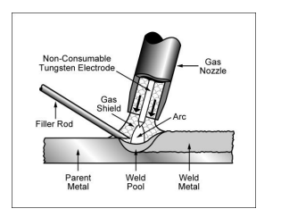
- It creates an arc between a non-consumable tungsten electrode and the workpiece.
- The weld area is protected by inert gas (argon, helium, or CO₂).
- Filler material is added separately (rod or wire).
- The tungsten electrode does not melt — it only generates heat.
Advantages of TIG Welding
- Extremely clean and precise welds.
- Better control than MIG, especially useful for thin sheet metal.
Pros | Cons
Clean, precise welds | Slower than MIG
Works with thin sheet | More expensive than MIG/MMA
Low distortion | Requires good operator skill
High-quality finish | Not ideal for thick sections
- Can be automated.
- Used for airtight/watertight applications.
- Low tooling cost
- Low labour intensity

What is Induction -pic & Flame Hardening?
These are surface-hardening processes that:
- Rapidly heat the outer surface of steel into the austenitic region
- Then rapidly cool it (quench) to form martensite, a very hard phase
This produces:
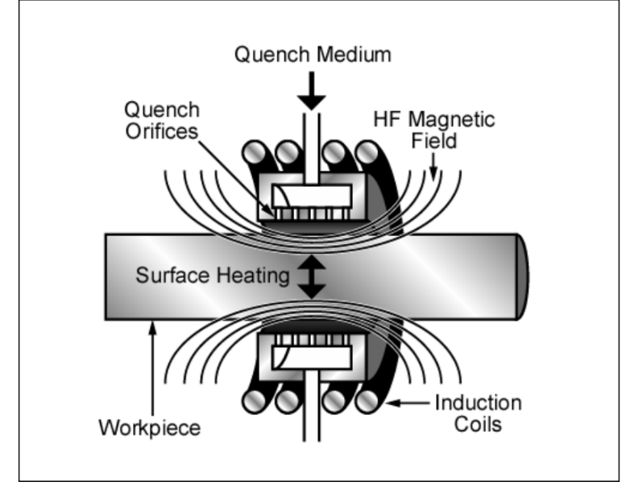
- A hard, wear-resistant surface
- A tough, machinable interior
Two Techniques:
1. Induction Hardening
- Uses a high-frequency electromagnetic field to induce eddy currents in the surface
- Localised heating — depth of hardening depends on frequency
- Very controlled, clean, and precise
2. Flame Hardening
- Uses gas burners to heat the surface
- Simpler and cheaper, but less precise
- Also followed by rapid cooling

LECTURE 8
What Is a Dislocation?
- A dislocation is a defect in the crystal structure of a metal.
- When metals deform, dislocations move — so stopping dislocations = increasing strength.
Hardening Mechanisms for Metals
1. Solid Solution Hardening (Chemistry-Based)
What happens:
- Solute atoms (e.g., carbon in iron) are added to the metal.
- These atoms distort the lattice around dislocations, making it harder for dislocations to move.
Example:
- Adding carbon to iron to make steel
Key Point:
- Strengthens metal by creating local strain fields that resist dislocation motion.
2. Precipitation Hardening (Microstructure-Based)
What happens:
- Tiny, dispersed particles (precipitates) form inside the metal.
- Dislocations are blocked by these particles, forcing them to bend or break around them.
Example:
- Aluminium-copper alloys (like Duralumin)
Key Point:
- Excellent for heat-treatable alloys — great strength-to-weight ratio.
3.Work Hardening (Strain Hardening, also Microstructure-Based)
What happens:
- Cold working (bending, rolling, hammering) increases dislocation density.
- Dislocations interact and tangle, making further movement more difficult.

Step-by-Step Process
1. Solutionizing
- Heat the alloy to the solid solution region (above T<sub>s</sub>, below T<sub>m</sub>)
- At this temp, all alloying elements dissolve in the matrix
2. Quenching
- Rapidly cool it to room temperature → freezes the structure
- Creates a super-saturated solid solution
3. Aging
- Reheat to a moderate temperature
- Over time, tiny precipitate particles form (the "second phase")
- These particles impede dislocation movement, increasing strength
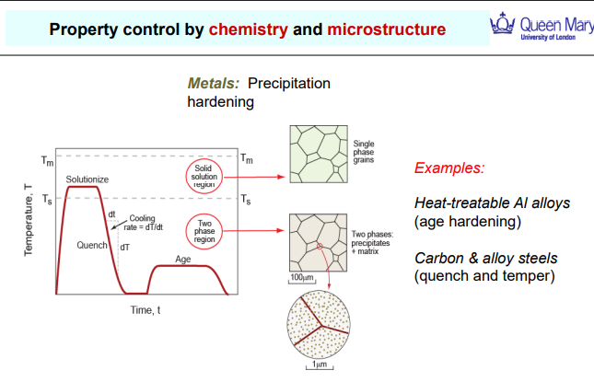

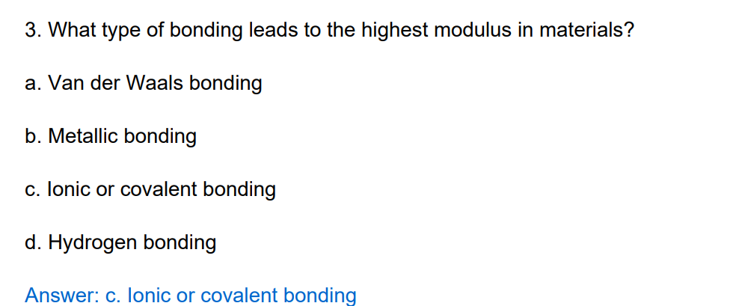
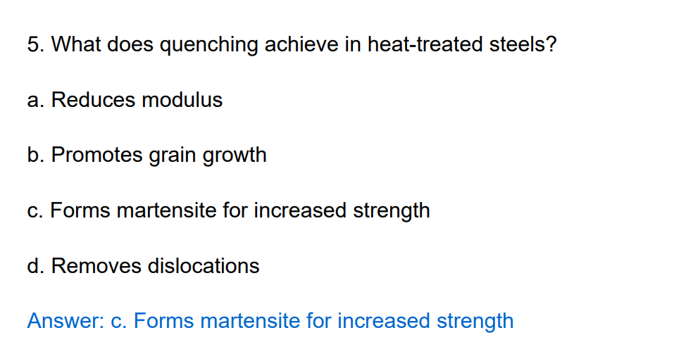
Why Other Options Are Wrong:
- a. Reduces modulus → Modulus doesn't significantly change with quenching.
- b. Promotes grain growth → Opposite: slow cooling promotes grain growth, not quenching.
- d. Removes dislocations → Quenching doesn't do this — annealing might.
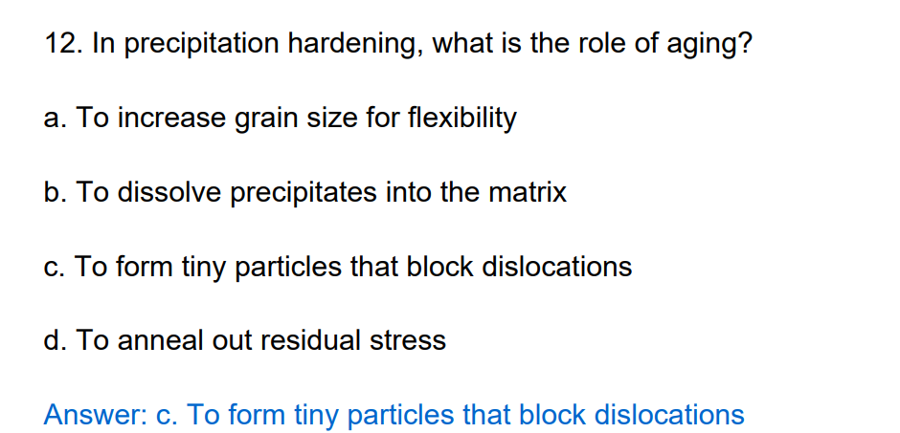
Common Fillers in Polymer Composites
Filler Type | Key Properties | Effect on Composite | Used In
Talc | Plate-like, increases stiffness, reduces shrinkage, low cost | Increases modulus, reduces toughness, reduces shrinkage | Automotive parts (e.g. dashboards)
Calcium Carbonate | Inexpensive, increases stiffness, increases density | Increases modulus, increases density, low cost filler | Consumer goods, packaging, PVC pipes
Glass Beads | Spherical, improves flow, increases stiffness | Improves modulus and processability, smooth surface finish | Medical devices, electrical casings
Mica | Layered, increases dimensional stability, barrier properties | Improves stiffness, dimensional stability, and heat resistance | Paints, insulation, high-performance plastics
Carbon Black | Improves UV resistance, electrical conductivity | Increases toughness, adds conductivity and UV stability | Tyres, automotive trims, cables
Silica | Hard, abrasion-resistant, improves thermal stability | Increases hardness and wear resistance | Sealants, coatings, high-wear parts
Wood Flour | Natural, biodegradable, low cost | Reduces cost, improves stiffness, slightly reduces toughness | Decking, furniture, wood-plastic composites
Alumina Trihydrate (ATH) | Flame retardant, endothermic decomposition | Adds flame retardancy, slightly reduces toughness | Electrical housings, flame-retardant plastics

